**Level 1: Start of Game - Input / Output Analysis**

A) You turn on the Simon game by pressing one of the four buttons. Pressing the red button will start a single player mode, pressing the green button will start co-op mode. If you press the yellow button the game will display the highest score. After selecting either single or co-op the game will start playing a pattern, from there you just repeat it.

B) IF (a button is pressed & the game is not on) THEN turn It on. IF (the red button is pressed) THEN start the game in single player. IF (the green button is pressed) THEN start the game in co-op mode. IF (the yellow button is pressed) THEN display the high score.

C)

|  |  |  |
| --- | --- | --- |
| Object | Action | Result |
| The Red Button | Push | If game is didn't start, start in single player, else record and check if that was the right color in the pattern. |
| The Green Button | Push | If game is didn't start, start in co-op mode, else record and check if that was the right color in the pattern. |
| The Blue Button | Push | If the game isn't on, turn it on, if the game is in progress, then record and check if that was the correct color in the pattern. |
| The Yellow Button | Push | If the game isn't on, or didn't start, show the high score. If the game is in progress, record and check if that was the right color in the pattern. |

D)

|  |  |  |
| --- | --- | --- |
| Object | Action | Meaning |
| The Red Button | Play Tone & Light | This will play a sound and light up depending on its color when showing a pattern. |
| The Blue Button | Play Tone & Light | This will play a sound and light up depending on its color when showing a pattern. |
| The Yellow Button | Play Tone & Light | This will play a sound and light up depending on its color when showing a pattern. |
| The Green Button | Play Tone & Light | This will play a sound and light up depending on its color when showing a pattern. |
| The LEDs | Light up, (1 of 4 colors) | These LEDs are under the buttons because when the game needs to light up a specific button it will be correctly correlated. |
| The Sounds | Play Sound | There are many different sounds, there is a sound when you input the correct color in the pattern, a sound when you input is not correct, when you start the game, it will tell you if you selected single player or co-op. |

**Level 2: Game Play - Input / Output Analysis**

A) After selecting a game mode (single player or co-op) the game will start level one and start showing a pattern. In our case it's Red, Green, Blue. You would then have to repeat the pattern in the correct order, firstly starting with red, then green, then finally blue. If you mess up any color throughout the pattern, you will fail and the game will restart.

B) IF (the player selected a game mode) THEN start playing the first pattern. IF (the game is on the 3-tone stage) THEN light up the Red button, then the green button, then finally the blue button. IF (the person presses the correct color in the pattern stage) THEN proceed onto the next color ELSE IF (they press the wrong the color) THEN end the game. IF (the color is correct) THEN continue the game. IF (the pattern is completed correctly) START THE NEW PATTERN.

C) IF (the red button is pressed) THEN move onto the next color. IF (the green button is pressed) THEN move onto the next color. IF (then blue button is pressed) THEN create and display the new pattern, then. IF (the wrong color in the pattern stage is pressed) THEN end the game.

D) IF (the correct button is pressed correlating the first color in the pattern) THEN move onto the next color ELSE IF (the incorrect color is pressed in the pattern) THEN end the game and reset to stage 1.

E)

|  |  |  |
| --- | --- | --- |
| Object | Action | Result |
| The Red Button | Push | If game is didn't start, start in single player, else record and check if that was the right color in the pattern. |
| The Green Button | Push | If game is didn't start, start in co-op mode, else record and check if that was the right color in the pattern. |
| The Blue Button | Push | If the game isn't on, turn it on, if the game is in progress, then record and check if that was the correct color in the pattern. |
| The Yellow Button | Push | If the game isn't on, or didn't start, show the high score. If the game is in progress, record and check if that was the right color in the pattern. |

F)

|  |  |  |
| --- | --- | --- |
| Object | Action | Meaning |
| The Red Button | Play Tone & Light | This will play a sound and light up depending on its color when showing a pattern. |
| The Blue Button | Play Tone & Light | This will play a sound and light up depending on its color when showing a pattern. |
| The Yellow Button | Play Tone & Light | This will play a sound and light up depending on its color when showing a pattern. |
| The Green Button | Play Tone & Light | This will play a sound and light up depending on its color when showing a pattern. |
| The LEDs | Light up, (1 of 4 colors) | These LEDs are under the buttons because when the game needs to light up a specific button it will be correctly correlated. |
| The Sounds | Play Sound | There are many different sounds, there is a sound when you input the correct color in the pattern, a sound when you input is not correct, when you start the game, it will tell you if you selected single player or co-op. |

**Level 3: Flowchart Conventions**

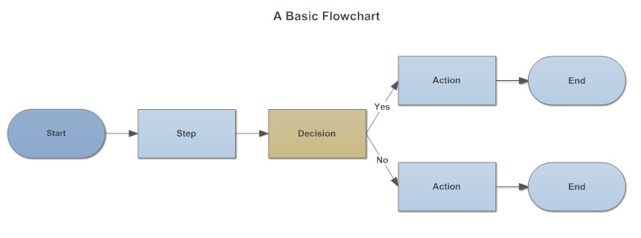

2.

**Input/Output:** This represents data that can be inputted and outputted.

**Process/Annotation:** A Process that takes place

**Online Storage:**  Online storage, that stores data.

**Offline Storage:** Local storage that is storing the data onboard somewhere rather than somewhere online.

**Document:** Examples are receiving a report, email or order.

**Display:** Used to indicate what information will get displayed within a process flow.

**Manual Input:** Represents manual input, like using a keyboard to input data.

**Manual Operation:**  Indicates a step that must be done manually rather than automatically.

**Preparation:** Separates between steps that prepare for work and steps that do the work.

**Connector:** Connects separate elements across one page.

3. This chart uses two of the same symbols (the action) and the (end)

**Level 4: Flowchart the Simon Game**

U,{0d9fd9ce-3642-48f9-87de-dd0ad9db0f8f}{223},10,10.304506699147382